IT 0014 / 0015 bib template mapping guide.
- Create custom template.
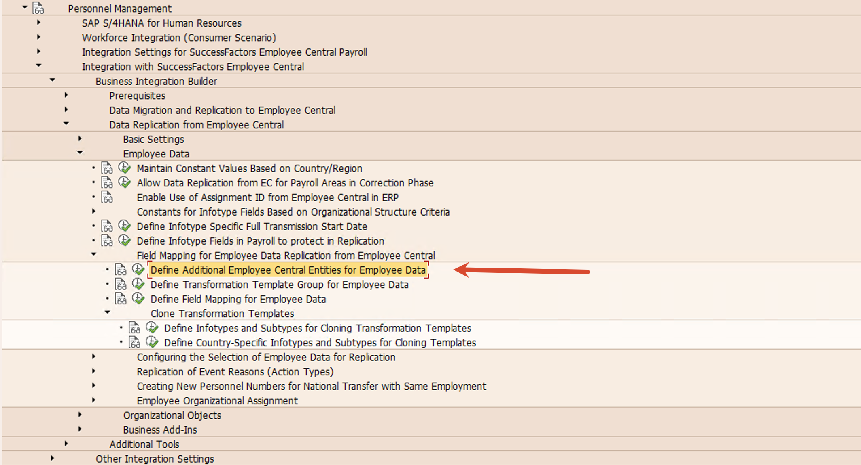

- You need create 2 templates. One for parent and the other for child element
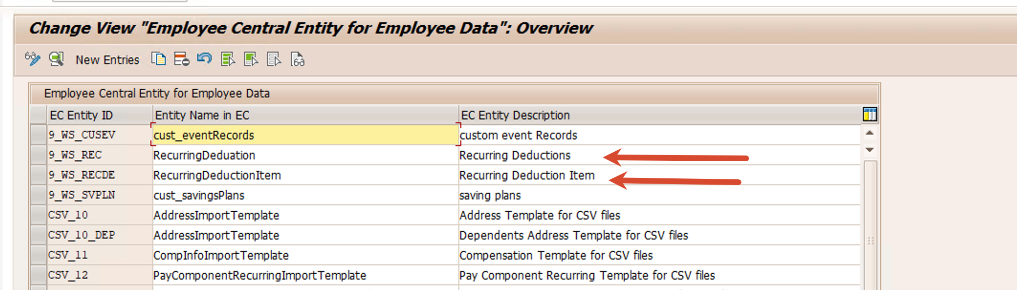
- Parent 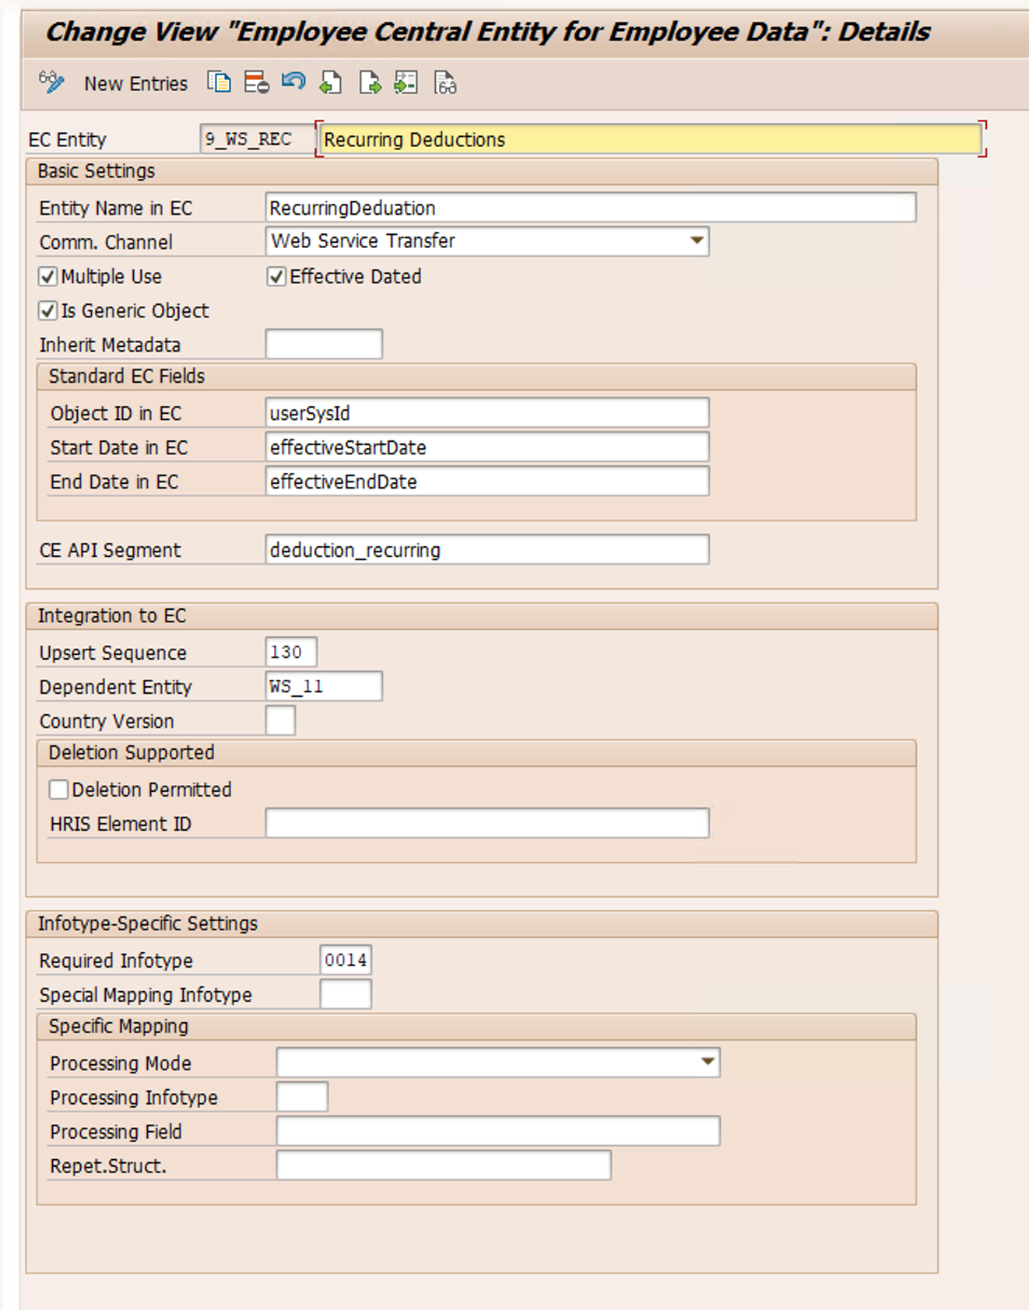
- Child
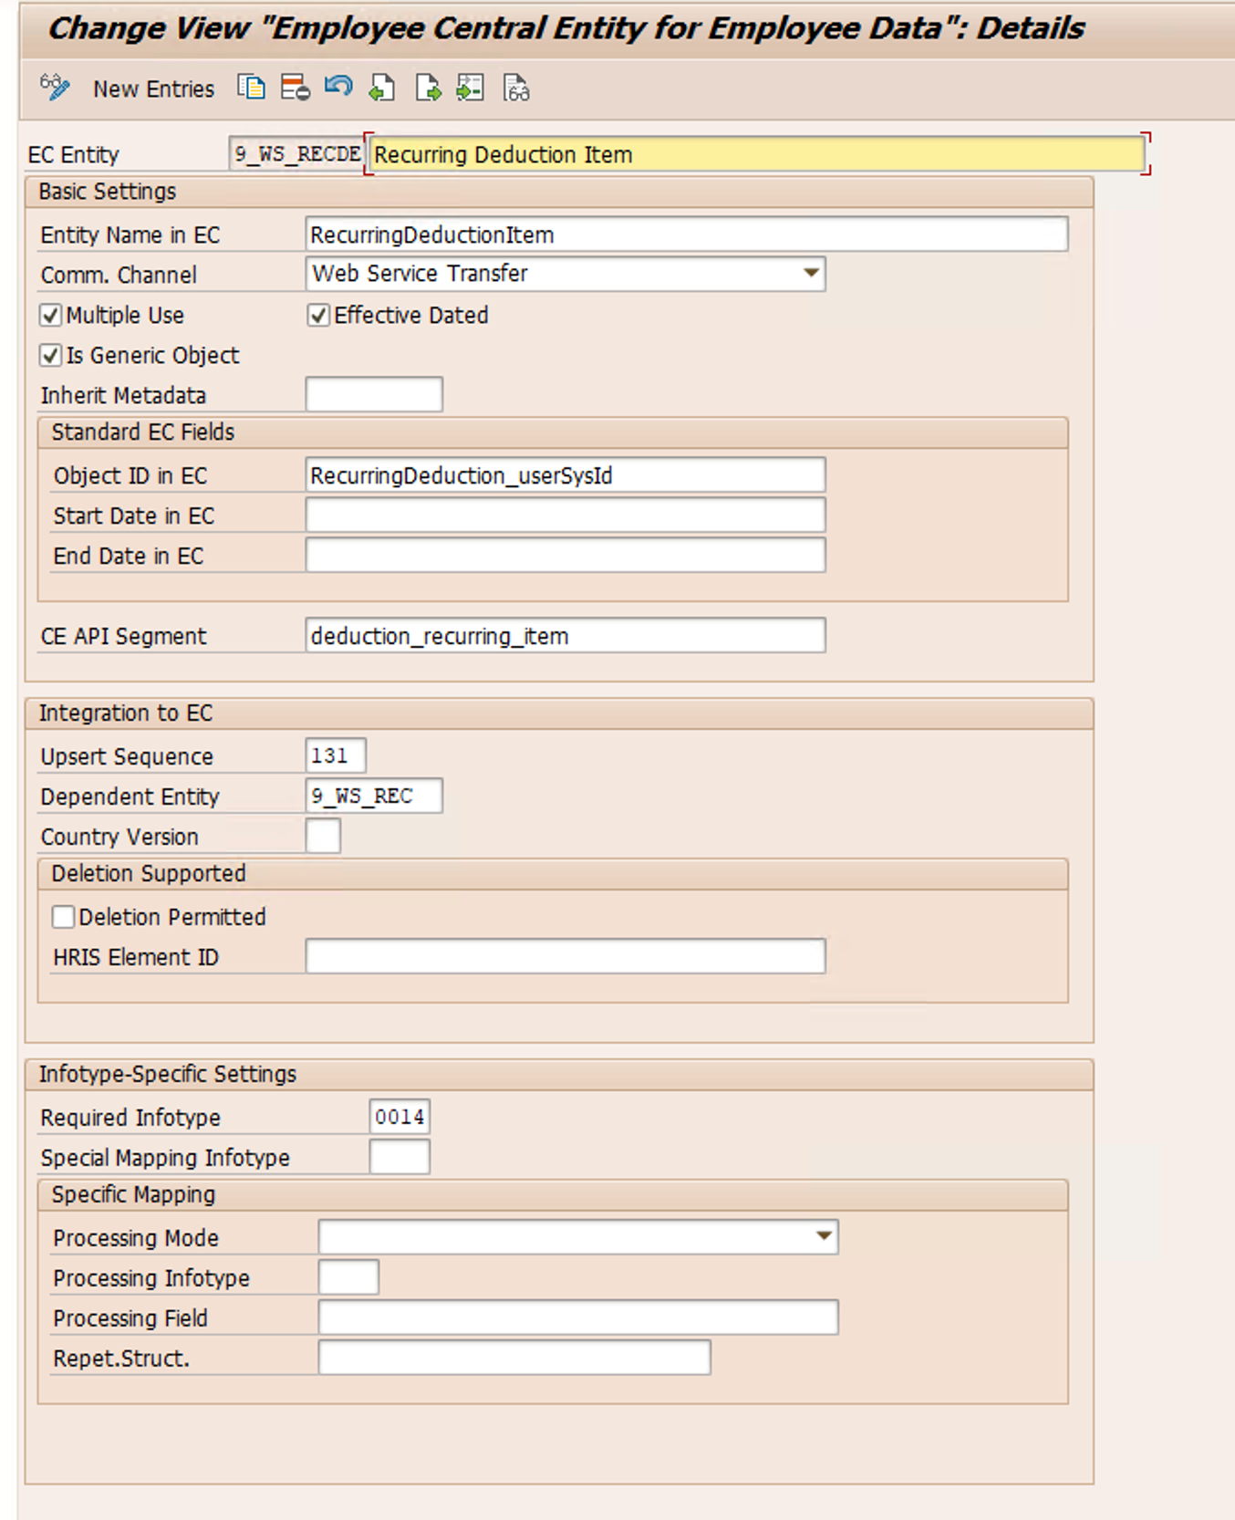

- For it0015, you can use the standard ws_13. But you also need to check if the fields in your metadata match the config in this template
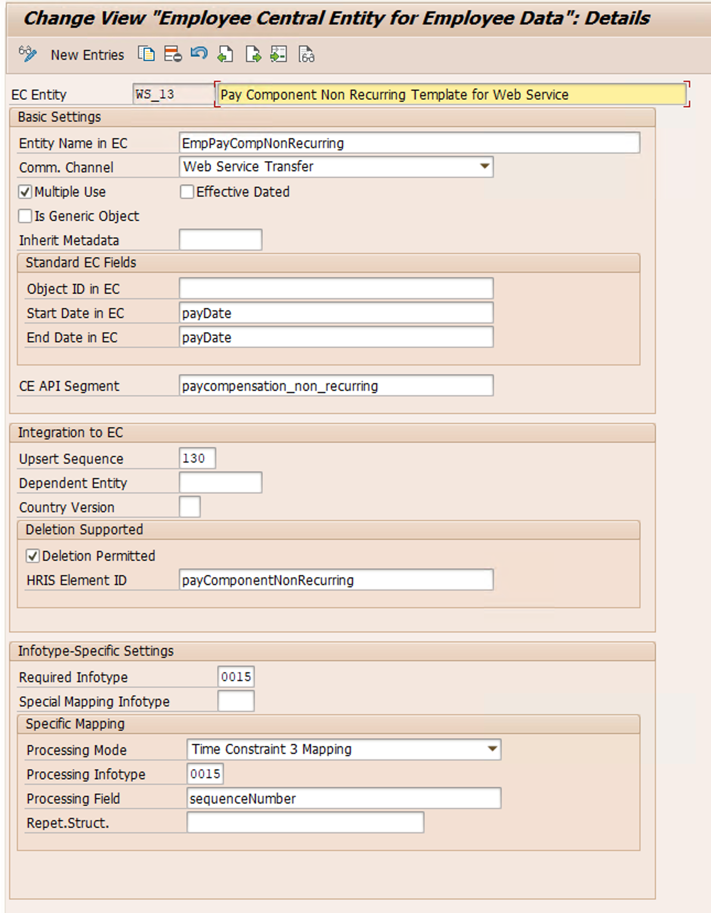

- In the bib mapping, you can add the templates you just created
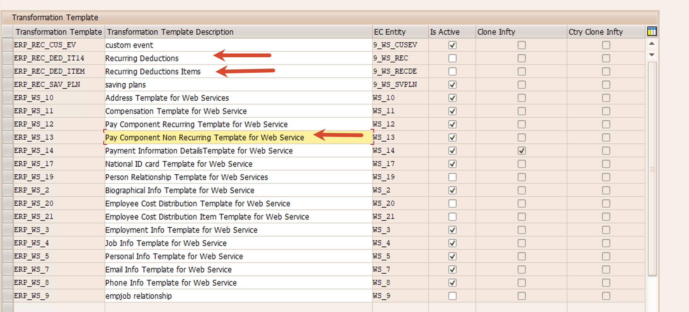

- The parent mapping is blank. this mapping is intentionally left blank.
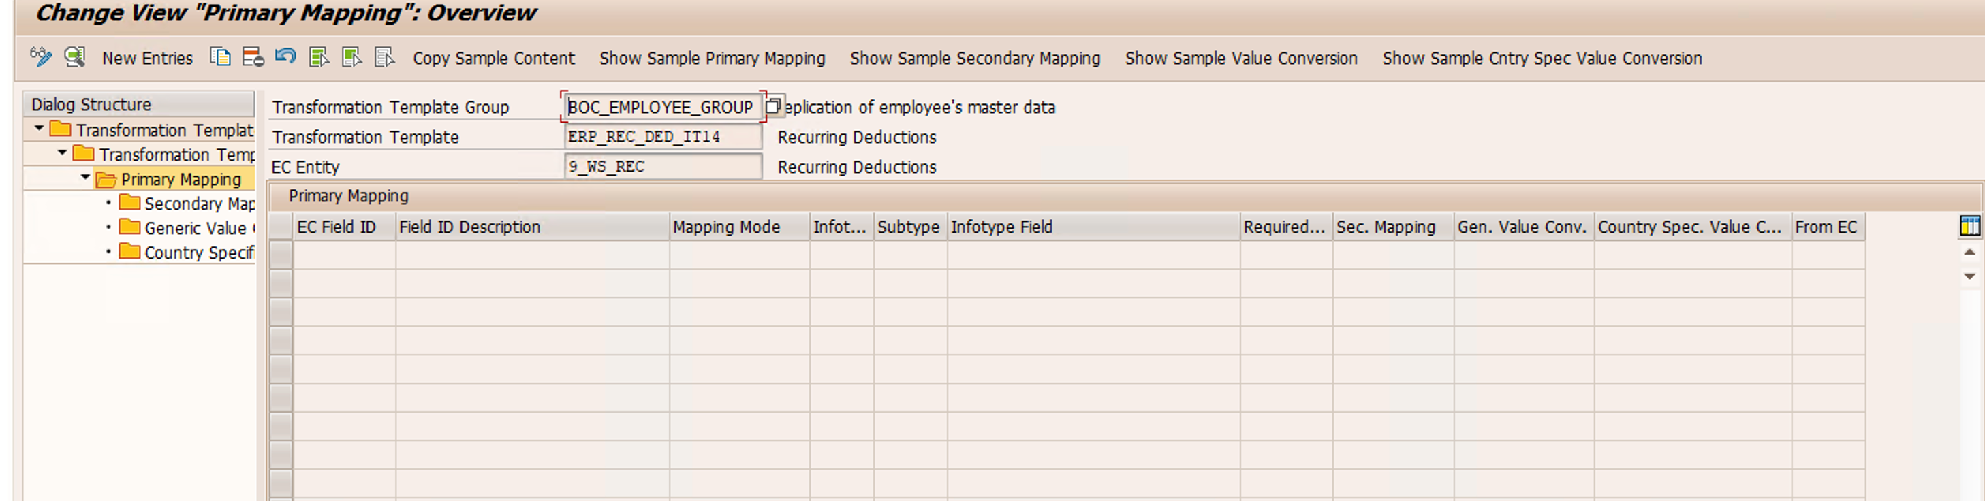
- The child mapping
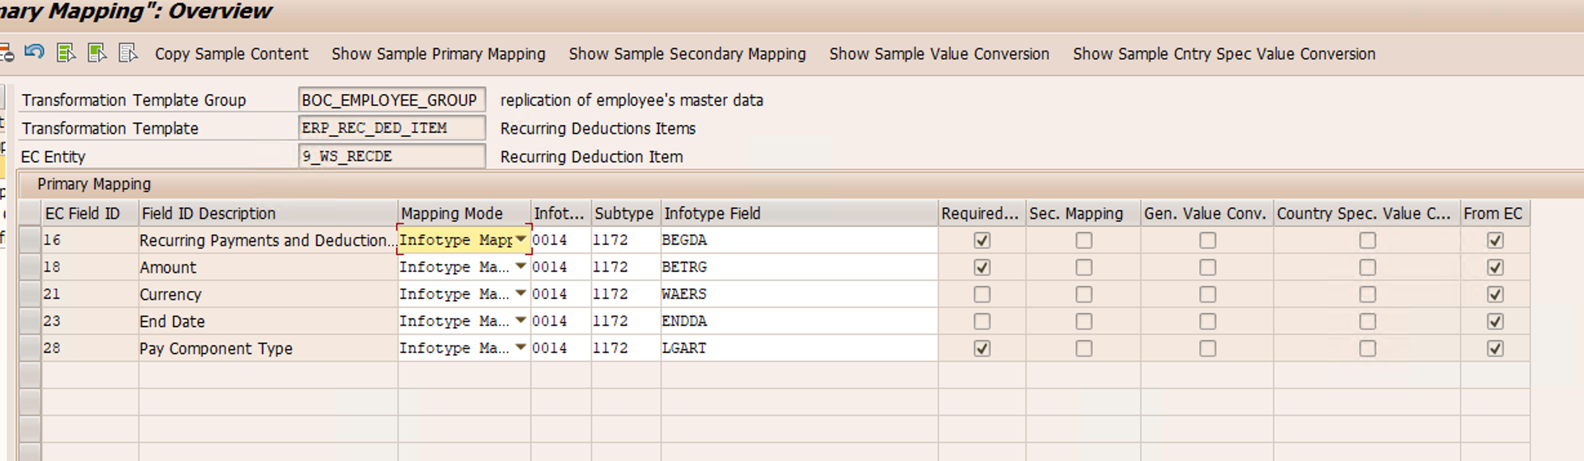

- It0015, ws 13


